Seth Cram

11/03/2021

CS270: HW3

**Backup Testing**

Backing up of a file and directory using Backup.sh:

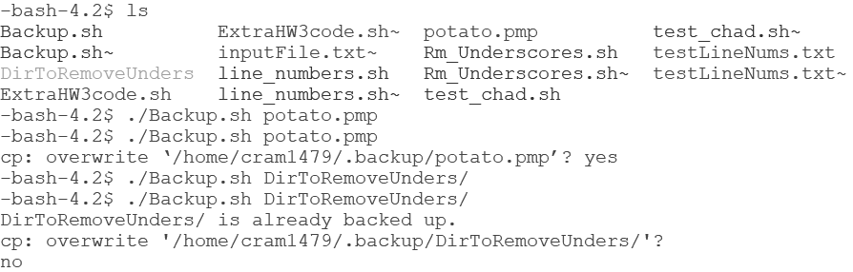

Resulting contents of backup directory:

